1. Dialog at login if wrong password…
2. Forgot my password not working
3. [I don't have a login - Register](http://admin.encoreapp.net/register) – not working

4. Whenever I go back or do a REFRESH in the browser this comes????

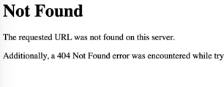

5. Put business name please – or am I seeing this because I am superadmin?

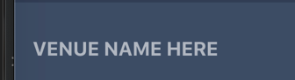

***6. Let’s remove this please.***



7. This is a required field. User needs to click the checkmark.



And let’s put a * next to all the required fields please:

Business name, contact name, contact phone, country, city, about, email, phone, location, discount levels, Category, min. order, pin code, main image, Terms

8. Change text to: ID and Company license and, if possible, please move to TAB in Business details.



9. The image upload you are using for main image and gallery images and ID images, can it show a **spinner** or an **hourglass** or something to let the user know something is happening?

And is it added to Firestore when the image is showing or do I have to also click SAVE?

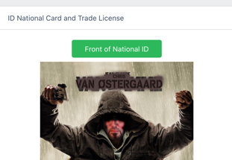

10. Can we show what is selected here, so the user and I know:

  




Basically like we do here:



11. Can the confirm text change to “Venue successfully updated!” – I don’t think the venueowner will know what “Chrisvenue” is…

